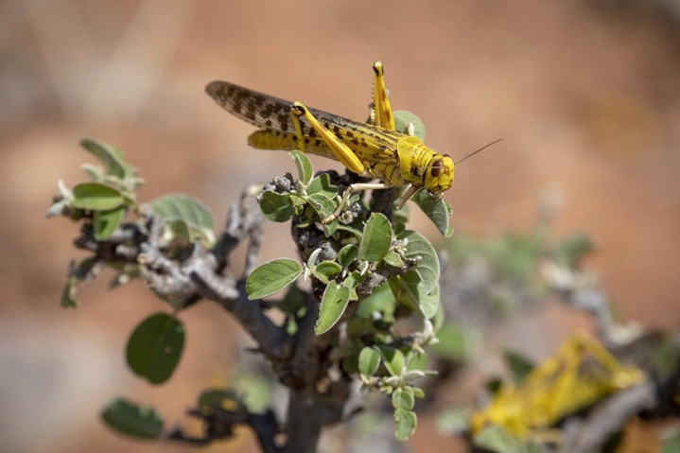

**Methodology Development and Validation of Criteria to Establish and Determine Different States of Desert Locusts Outbreaks**



MODEL OUTPUTS DESCRIPTION

**Submitted to:**



Procurement Unit,

IGAD Climate Prediction and Application Centre (ICPAC),

Ngong town, Kibiku area,

P.O. Box 10304-00100, Nairobi, Kenya

Tel (+254) 20-3514426

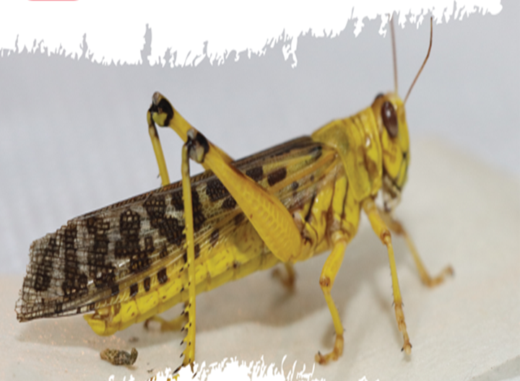

**Submitted by:**

Galana Plaza, 5th Floor, Wing D, Galana Road

P. O. Box 17227 - 00100, NAIROBI – KENYATelephone: +254-726705239, +254-724528575, +254-782001200

Email: [vivianne.meta@locateit.co.ke](mailto:vivianne.meta@locateit.co.ke)

info@locateit.co.ke

Website: [www.locateit.co.ke](http://www.locateit.co.ke)

Table of Contents

ELRP MODEL OUTPUTS DESCRIPTION 3

1. Historical breeding Suitability Outputs 3

2. Gregarization and Swarming Modelling Outputs 5

3. Swarm Trajectory Modelling outputs 7

4. Feeding Susceptibility Modelling Outputs 9

5. Criteria development Framework Modelling Outputs 12

Table of Figures

*Figure 1:General breeding Suitability* 3

*Figure 2:Temporal breeding Suitability* 4

*Figure 3: Gregarization and swarming sample output for the year 2023* 5

*Figure 4:Combiled gregarization and swarming output* 6

*Figure 5:Projected trajectory simulation interface* 7

*Figure 6:Swarm trajectory vector with timesteps for each swarm sighting* 8

*Figure 7: Desert Locust stay durations for each swarm coverage* 9

*Figure 8:Sample attributes for one of the coverage polygons* 10

*Figure 9: Key fields in the vector data* 10

*Figure 10: Feeding susceptibility raster* 11

*Figure 11: Sample visualization of the outbreak stages* 12

# ELRP MODEL OUTPUTS DESCRIPTION

## Historical breeding Suitability Outputs

The breeding suitability outputs are organized into two:

#### General breeding Suitability based on all historical observations

This output portrays the general breeding grounds in the horn of Africa region with the final output being obtained as a reclassified raster. This is what the model provides as the final output. The reclassified raster has four classes this being:

Class 1: Unsuitable breeding grounds (color hex = **# BDBEBE**)

Class 2: Low suitability breeding grounds (color hex = **# 0070FF**)

Class 3: Moderate suitability breeding grounds (color hex = **# 267300**)

Class 4: High Suitability breeding grounds (color hex = **# FF2B18**)

Below is a sample visualization of the general breeding suitability

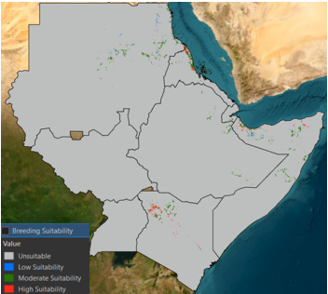

*Figure 1:General breeding Suitability*

**NB: The model also provides a csv file representing the actual locations on the ground for the different breeding grounds that can be utilized for response. The csv file is provided in the shared outputs folder.**

#### Temporal breeding suitability generated on a monthly basis

This output portrays the temporal breeding grounds in the horn of Africa region with the final output being obtained as a reclassified raster. This is what the model provides as the final output. The reclassified raster has four classes this being:

Class 1: Unsuitable breeding grounds (color hex = **# BDBEBE**)

Class 2: Low suitability breeding grounds (color hex = **#F2FE2A**)

Class 3: Moderate suitability breeding grounds (color hex = **#33B3FD**)

Class 4: High Suitability breeding grounds (color hex = **#FF2B18**)

Below is a sample visualization of the temporal breeding suitability for the month of January 2025

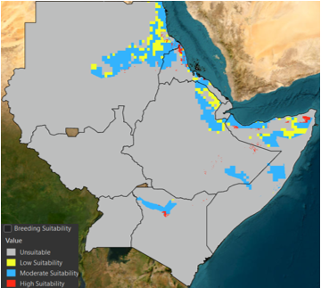

*Figure 2:Temporal breeding Suitability*

**NB: The model also provides a csv file for each temporal output representing the actual locations on the ground for the different breeding grounds that can be utilized for response. The csv file is provided in the shared outputs folder.**

## Gregarization and Swarming Modelling Outputs

The model product is in form of a raster dataset, portraying the regions conducive for desert locust to transition from solitarious state to gregarious state which later leads to swarm formation. The output is provided in a continuous raster format. The datasets are provided in the outputs folder.

*Figure 3: Gregarization and swarming sample output for the year 2023*

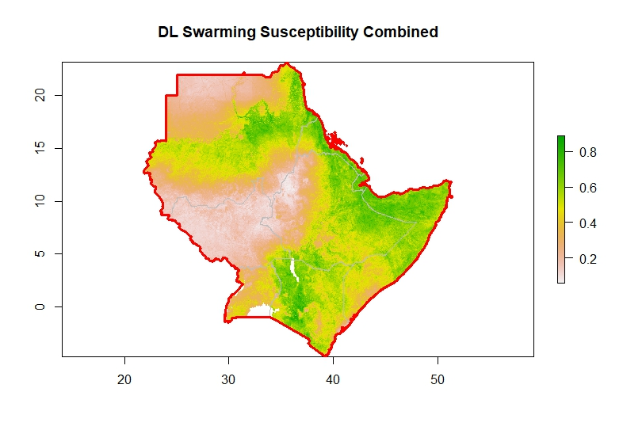

*Figure 4:Combiled gregarization and swarming output*

## Swarm Trajectory Modelling outputs

The model also exports a GeoJSON file containing the trajectories of initial set swarm locations. To enhance user interaction, a time slider is included, allowing users to step through the simulation and explore how the swarm disperses across the region at different time intervals. This feature enables an intuitive understanding of the swarm’s behavior and progression over the chosen simulation period.

Note that the model will be simulating real-time swarm trajectories once a swarm occurrence has been reported from the field. To facilitate further analysis, the generated trajectory data is saved as GeoJSON files having the dates and locations of the swarms at each simulation step. This geojson can be utilized to visualize the simulation across different time steps for each swarm. The geojson is provided in the outputs drive folder shared.

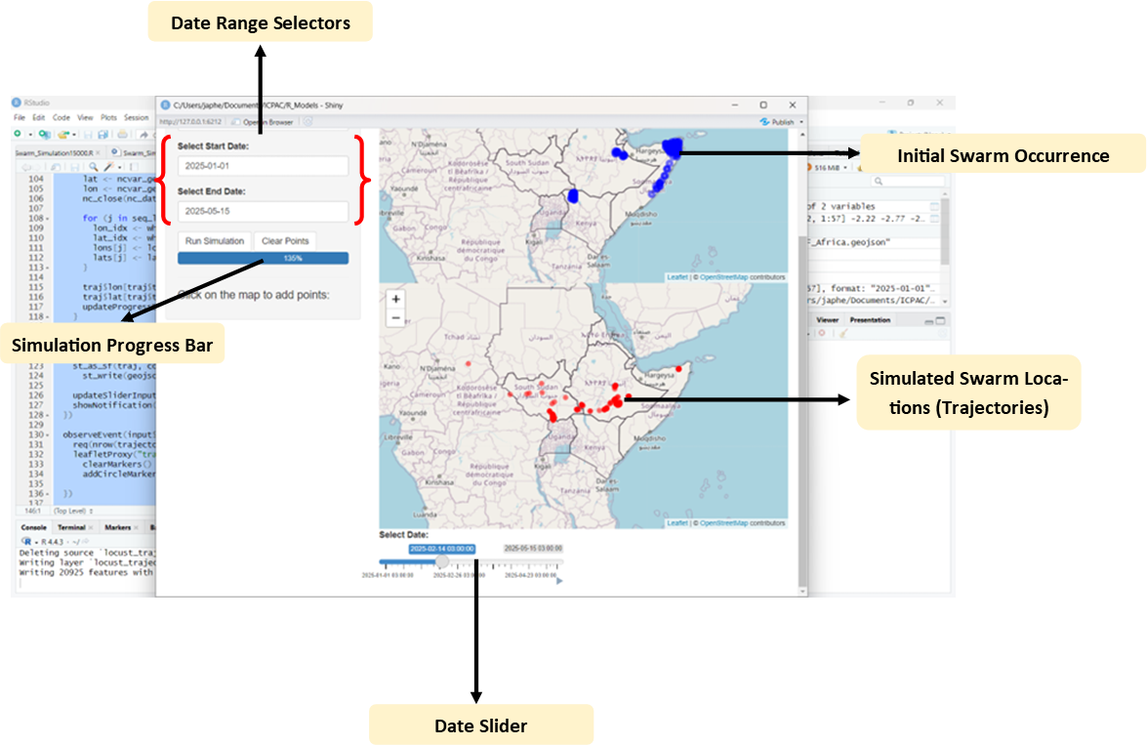

*Figure 5:Projected trajectory simulation interface*

*Figure 6:Swarm trajectory vector with timesteps for each swarm sighting*

## Feeding Susceptibility Modelling Outputs

The feeding suitability model generates two outputs representing the stay duration of a desert locust and the coverage densities of the desert in a certain region upon sighting. The two outputs are:

#### Coverage vector data in form of shapefiles containing information for each individual locust sighting.

The key column for visualization of this output is the ***“day_feedin”*** column. The model automatically generates the coverage polygons with the distinguishing visualizations based on the ***“day_feedin”*** column. Below is a representation of the output visualized and some of the contents of each coverage polygon for individual swarm sizes.

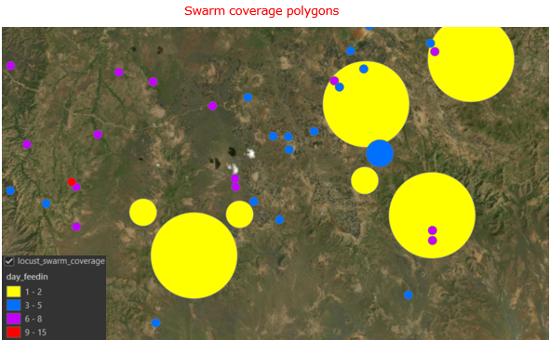

*Figure 7: Desert Locust stay durations for each swarm coverage*

The symbology categories for the ***“day_feedin”*** are as portrayed below:

* 1-2 days (color hex = **#FFFF00**)
* 1-2 days (color hex = **#0070FF**)
* 1-2 days (color hex = **#C500FF**)
* 1-2 days (color hex = **#FF0000**)

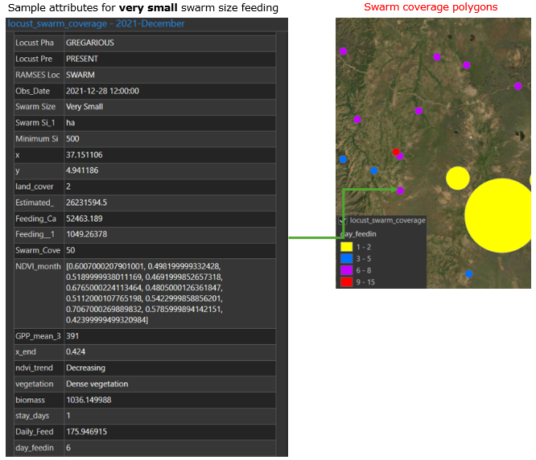

*Figure 8:Sample attributes for one of the coverage polygons*

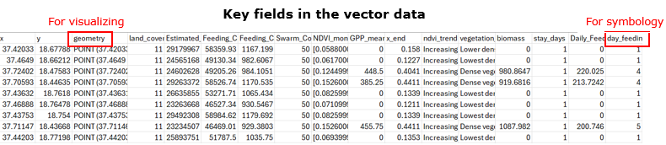

*Figure 9: Key fields in the vector data*

#### Raster data portraying the general feeding susceptibility based on the historical swarm observation from 2021 to present.

The raster data also generated by the model provides a spatial distribution of the historical stay duration with the data coming as continuous data. The final output is then reclassified using the below four classes.

* 1-2 days
* 2-4 days
* 5-7 days
* 8 onwards

***NB: the model does not do the reclassification. This should be done at the visualization stage.***

Below is a representation of the raster data

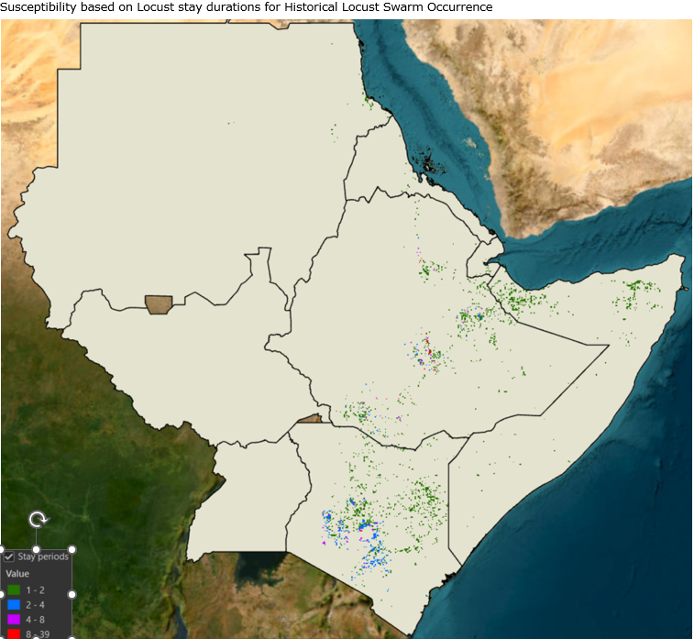

*Figure 10: Feeding susceptibility raster*

## Criteria development Framework Modelling Outputs

The data Shared via the drive link representing the outbreak criteria stages should be basically used to visualize the data via the web based on a column called "outbreak stages". The column has four classes, i.e., Calm Stage, Alarm Stage, Alert Stage, and Crisis Stage. The classes should be visualized as green, orange, light red.

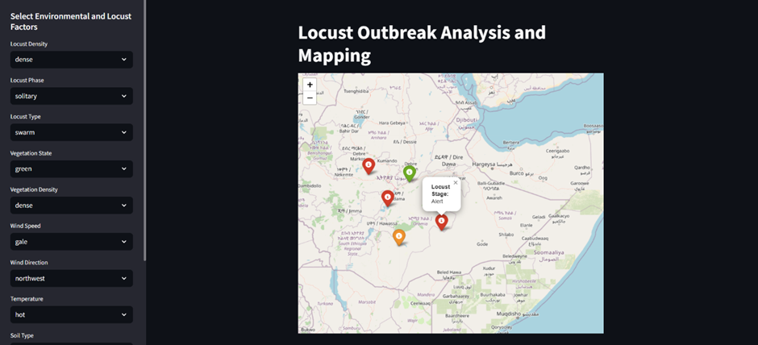

*Figure 11: Sample visualization of the outbreak stages*